WEEK-1
Exercise 1: Implementing the Singleton Pattern
Scenario:
You need to ensure that a logging utility class in your application has only one instance throughout the application lifecycle to ensure consistent logging.
Steps:
- Create a New Java Project:
  - Create a new Java project named SingletonPatternExample.
- Define a Singleton Class:
  - Create a class named Logger that has a private static instance of itself.
  - Ensure the constructor of Logger is private.
  - Provide a public static method to get the instance of the Logger class.
- Implement the Singleton Pattern:
  - Write code to ensure that the Logger class follows the Singleton design pattern.
- Test the Singleton Implementation:
  - Create a test class to verify that only one instance of Logger is created and used across the application.

Project Overview This project demonstrates the Singleton design pattern by implementing a logging utility class. The primary objective is to guarantee that only a single instance of the logger exists during the application's lifecycle, ensuring consistent logging across the entire system.
Project Structure
- SingletonPatternExample/src/Logger.java: Contains the Singleton logic.
- SingletonPatternExample/src/Main.java: Contains the execution and validation logic.
Implementation Details
1. The Singleton Class (Logger.java) The Logger class is structured to strictly control its own instantiation.
- It contains a private static variable to hold the sole instance of the class.
- The constructor is declared private to prevent any external classes from creating a new instance using the new keyword.
- A public static method (getInstance()) is exposed to provide global access to the instance. It initializes the instance only if it does not already exist.
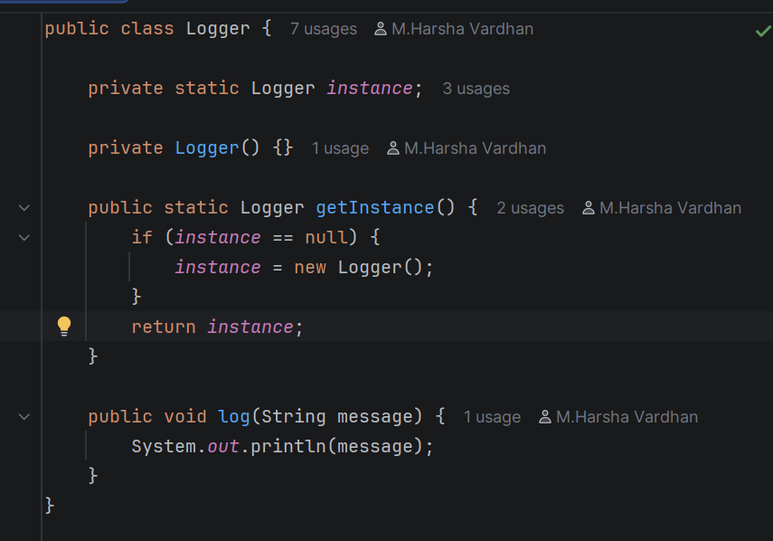

2. The Testing Execution (Main.java) The Main class serves as the driver to verify that the Singleton pattern was implemented correctly.
- It retrieves the logger instance twice and assigns them to logger1 and logger2.
- It uses the equality operator (==) to compare the memory references of both variables, proving that both variables point to the exact same object in memory.
- It calls the log() method to ensure the utility works as intended.
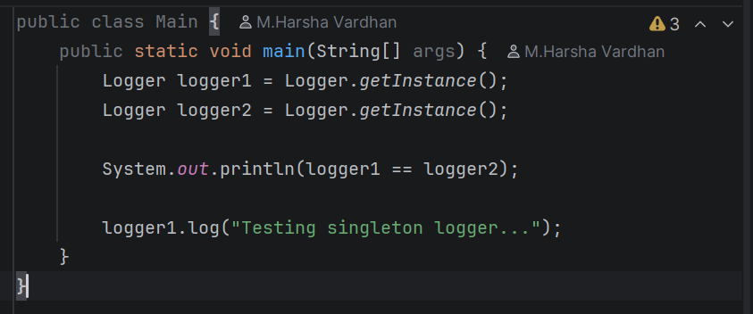

Execution Result
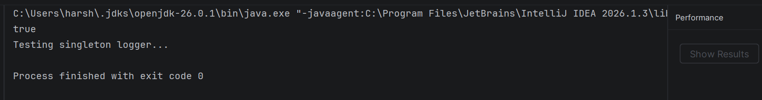

Exercise 2: Implementing the Factory Method Pattern
Scenario:
You are developing a document management system that needs to create different types of documents (e.g., Word, PDF, Excel). Use the Factory Method Pattern to achieve this.
Steps:
- Create a New Java Project:
  - Create a new Java project named FactoryMethodPatternExample.
- Define Document Classes:
  - Create interfaces or abstract classes for different document types such as WordDocument, PdfDocument, and ExcelDocument.
- Create Concrete Document Classes:
  - Implement concrete classes for each document type that implements or extends the above interfaces or abstract classes.
- Implement the Factory Method:
  - Create an abstract class DocumentFactory with a method createDocument().

Exercise: Implementing the Factory Method Pattern
Project Overview This project demonstrates the Factory Method design pattern by implementing a flexible document generation system. The primary objective is to define an interface for creating objects but allow subclasses to alter the type of objects that will be created, promoting loose coupling within the application.
Project Structure
- Document.java: The common interface for all document products.
- DocumentFactory.java: The abstract creator class declaring the factory method.
- WordDocument.java, PdfDocument.java, ExcelDocument.java: Concrete product implementations.
- WordFactory.java, PdfFactory.java, ExcelFactory.java: Concrete creator implementations.
- Main.java: The execution logic validating the pattern.
Implementation Details
1. Core Interface and Products The Document interface dictates the standard behavior that all concrete documents must implement.
public interface Document {
void open();
}
2. The Factory Logic The DocumentFactory acts as the abstract creator, delegating the instantiation logic to its subclasses.
public abstract class DocumentFactory {
public abstract Document createDocument();
}
Each specific factory subclass overrides the creation method to return the corresponding document instance.
Java
public class WordFactory extends DocumentFactory {
@Override
public Document createDocument() {
return new WordDocument();
}
}
3. The Testing Execution (Main.java) The Main class acts as the client. It leverages the factories to instantiate the documents, meaning the client code remains completely decoupled from the specific concrete document classes.
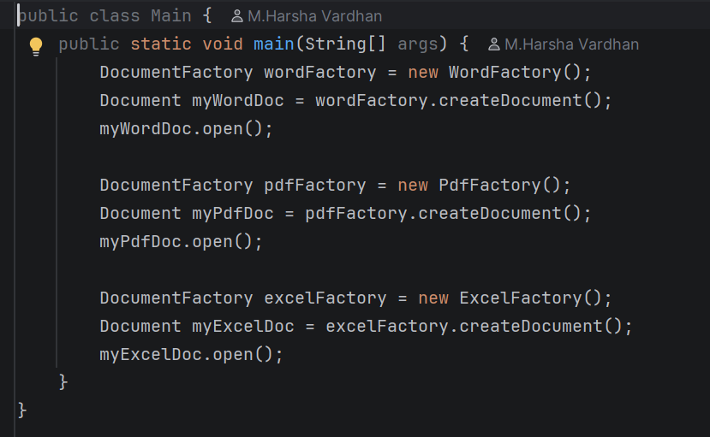
Execution Result :
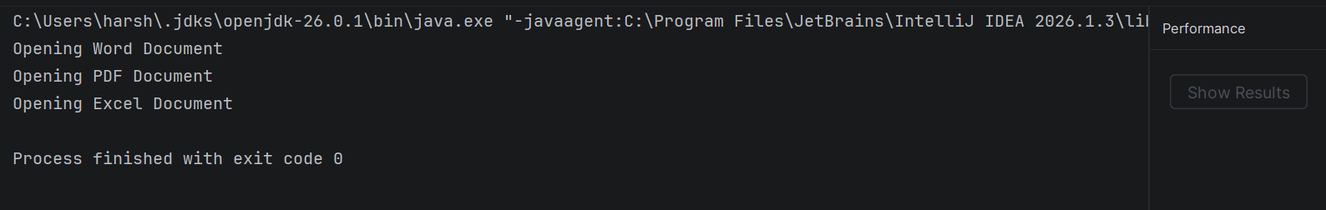

Exercise: Implementing Search Algorithms
Project Overview
This project demonstrates fundamental search algorithms by implementing a system to find specific products within a catalog. The primary objective is to showcase the mechanics of both linear search and binary search when operating on an array of custom objects.
Project Structure
- Product.java: The data model representing an item in the catalog.
- SearchEngine.java: The utility class containing the search algorithms.
- Main.java: The execution logic validating the search methods.
Implementation Details
1. The Data Model (Product.java)
The Product class serves as a blueprint for the items being searched.
- It contains basic attributes: productId, productName, and category.
- The constructor initializes these fields when a new product object is instantiated.
Java
public class Product {
int productId;
String productName;
String category;

public Product(int productId, String productName, String category) {
this.productId = productId;
this.productName = productName;
this.category = category;
}
}
2. Search Algorithms (SearchEngine.java) The SearchEngine class provides two distinct static methods for locating a Product by its targetId.
- linearSearch(): Iterates through the array sequentially from the first element to the last, returning the product if a matching ID is found.
- binarySearch(): Efficiently searches a sorted array by repeatedly dividing the search interval in half to locate the target ID.
public class SearchEngine {
public static Product linearSearch(Product[] products, int targetId) {
for (int i = 0; i < products.length; i++) {
if (products[i].productId == targetId) {
return products[i];
}
}
return null;
}
public static Product binarySearch(Product[] products, int targetId) {
int left = 0;
int right = products.length - 1;
while (left <= right) {
int mid = left + (right - left) / 2;
if (products[mid].productId == targetId) {
return products[mid];
}
if (products[mid].productId < targetId) {
left = mid + 1;
} else {
right = mid - 1;
}
}
return null;
}
}
3. The Testing Execution (Main.java) The Main class initializes a pre-sorted array of Product objects and acts as the driver for the program.
- It tests the linear search functionality by searching for product ID 102.
- It tests the binary search functionality by searching for product ID 104.
- The results are printed to the console based on whether the object was successfully returned or not.
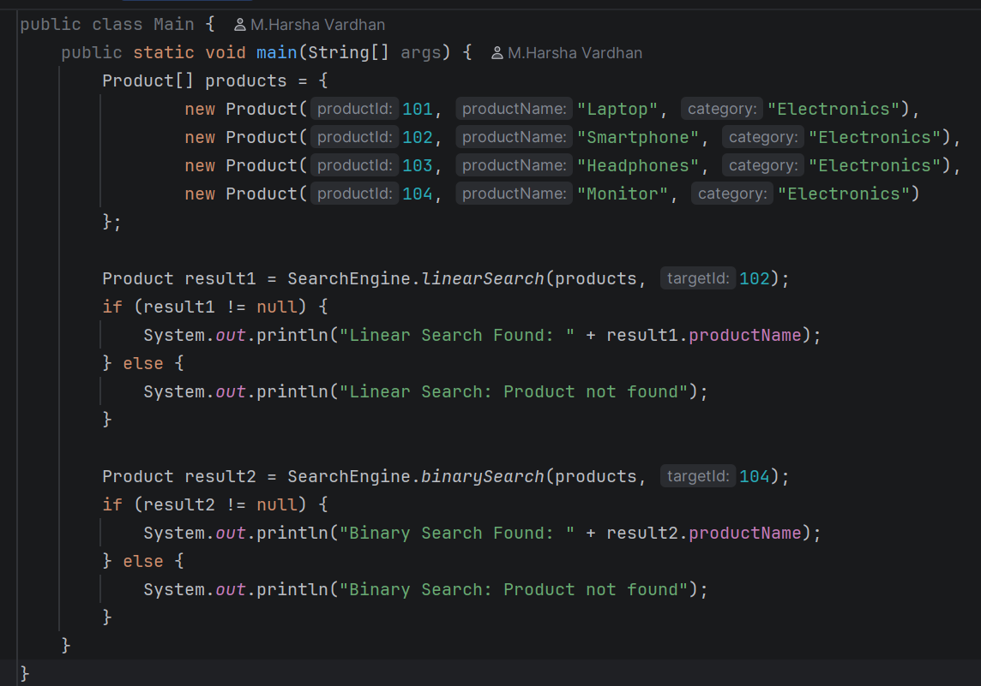

Execution Result:

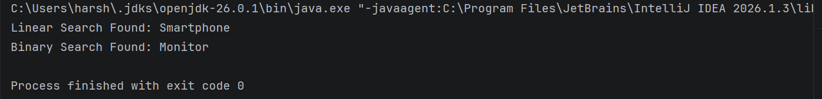

Exercise 7: Financial Forecasting
Scenario:
You are developing a financial forecasting tool that predicts future values based on past data.
Steps:
- Understand Recursive Algorithms:
  - Explain the concept of recursion and how it can simplify certain problems.
- Setup:
  - Create a method to calculate the future value using a recursive approach.
- Implementation:
  - Implement a recursive algorithm to predict future values based on past growth rates.
- Analysis:
  - Discuss the time complexity of your recursive algorithm.
  - Explain how to optimize the recursive solution to avoid excessive computation.

Project Overview This project demonstrates the use of recursive algorithms to build a simple financial forecasting tool. The primary objective is to predict the future value of an investment over a specific number of years based on a fixed annual growth rate, highlighting both the mechanics and the potential limitations of recursive programming.
Concept: Understanding Recursive Algorithms
Recursion is a programming technique where a method calls itself to solve a smaller instance of the same problem. A recursive algorithm always requires two main components:
- Base Case: A condition that stops the recursion from continuing indefinitely.
- Recursive Step: The part of the method that breaks the problem down and calls itself.
Recursion can simplify complex problems by breaking them into highly readable, self-contained mathematical steps, often replacing complex looping logic.
Implementation Details
The Recursive Setup (Forecast.java) The calculateFutureValue method handles the recursive logic.
- It uses a base case to check if years is 0. If so, it returns the accumulated presentValue.
- For the recursive step, it calculates the new value for one year presentValue + (presentValue * growthRate) and passes this new value back into itself while decrementing the years left to process.
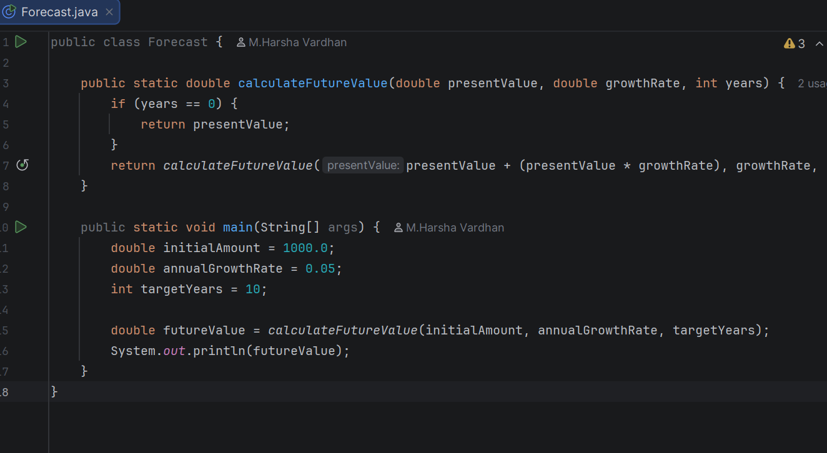

Execution Result:
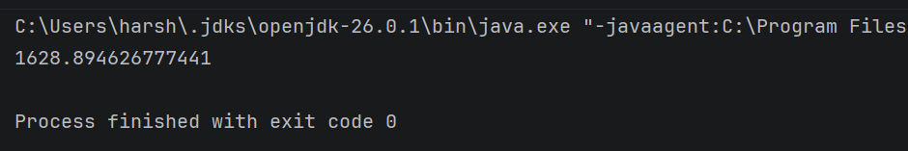

PL/SQL Programming

Exercise 1: Control Structures

Scenario 1: The bank wants to apply a discount to loan interest rates for customers above 60 years old.
  - Question: Write a PL/SQL block that loops through all customers, checks their age, and if they are above 60, apply a 1% discount to their current loan interest rates.
Scenario 2: A customer can be promoted to VIP status based on their balance.
  - Question: Write a PL/SQL block that iterates through all customers and sets a flag IsVIP to TRUE for those with a balance over $10,000.
Scenario 3: The bank wants to send reminders to customers whose loans are due within the next 30 days.
  - Question: Write a PL/SQL block that fetches all loans due in the next 30 days and prints a reminder message for each customer.
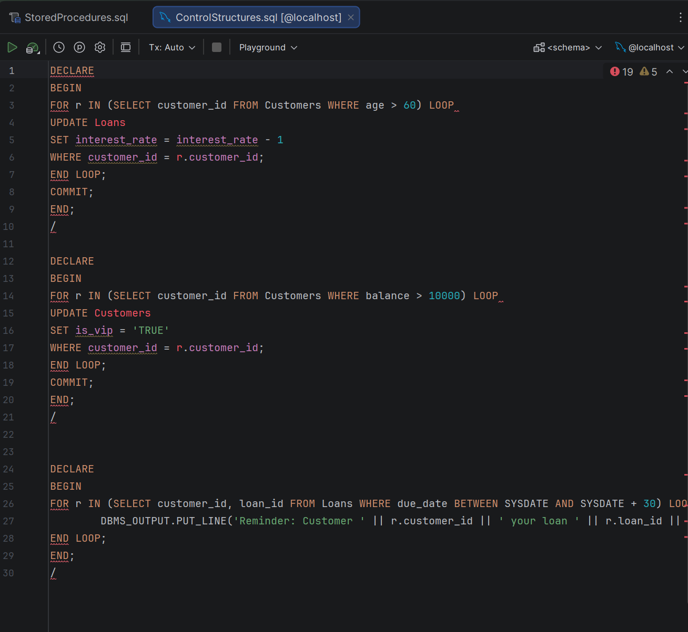
Exercise 3: Stored Procedures

Scenario 1: The bank needs to process monthly interest for all savings accounts.
  - Question: Write a stored procedure ProcessMonthlyInterest that calculates and updates the balance of all savings accounts by applying an interest rate of 1% to the current balance.

Scenario 2: The bank wants to implement a bonus scheme for employees based on their performance.
  - Question: Write a stored procedure UpdateEmployeeBonus that updates the salary of employees in a given department by adding a bonus percentage passed as a parameter.

Scenario 3: Customers should be able to transfer funds between their accounts.
Question: Write a stored procedure TransferFunds that transfers a specified amount from one account to another, checking that the source account has sufficient balance before making the transfer.

